MODS report of uranium occurrences on the mineral licence 032195M.

WHITE BEAR URANIUM #3

DESCRIPTION OF DEPOSIT
The showing consists of several large (< 10 to 20 kg) tabular radioactive boulders interpreted to the sub-outcrop of biotite rich metatuff, assigned to the Ordovician Bay du Nord Group.
METAL/MINERAL CONTENT
Sample Uppm %U3O8 Pounds per tonne U3O8 Desc.
(calculated) (calculated)
54336A 4745.8 0.56 12.31 boulder
54338 3968.9 0.47 10.30 boulder
54334 2158.3 0.25 5.60 outcrop
54335 1333.2 0.16 3.46 boulder
54339 1249.3 0.15 3.24 boulder
54337 726.5 0.09 1.88 boulder
Rock chip aggregates comprising 2-3 kg each (July 2005 results, Commander Resources company website)
Sample U3O8 Pounds per tonne U3O8 Grab sample
(assay) (calculated) description
54334 0.512 11.26 angular boulder
54336 0.754 16.59 angular boulder
54345 0.564 12.41 angular boulder
(August 2005 results, Commander Resources company website)

GEOCHEMICAL EXPRESSION
Uranium assays of grab samples from radioactive zones in the area of White Bear showing (O'Brien and Tomlin, 1985).
Sample No. Rock Type U (g/t)
1940601 nonwelded tuff 3,990
1940603 nonwelded tuff 4,290
1940604 nonwelded tuff 4,240
1940605 nonwelded tuff 4,330
1940606 nonwelded tuff 4,240

DOUCETTE PROSPECT

METAL/MINERAL CONTENT
Sixteen composite rock chip samples returned values ranging from 0.13% to 1.32% U308. Six of the samples contained in excess of 0.67% U308 (Commander Resources Ltd. press release, Nov. 1, 2005).
Significant uranium values in drill core at Doucette are shown below
DDH# From To Length %U308 lb/ton U308
WBR-07-09 15.0 15.4 0.40m 0.10 2.0
WBR-07-10 191.6 192.0 0.40m 0.11 2.2
WBR-07-13 16.5 16.8 0.30m 0.04 0.8
(Commander Resources press release, June 4, 2007).

STRUCTURE OF DEPOSIT
Shape: Undefined
Shape Modifier: Folded
Length (m): 1500
Width (m): 150

GEOPHYSICAL EXPRESSION
A close spaced grid of magnetic surveying on the White Bear area covered both boulder fields at the Doucette and #3 uranium prospects, which are separated by about 500 metres. The northern and southern portions of the grid show a low level, flat response, while a central 300 metre wide belt shows a very active magnetic response. The active magnetic response covers a portion of the Doucette Prospect and extends for 300 metres further up ice. Magnetic signature in this area is consistent with the measured response of the uranium bearing rocks of the Doucette Showing and may represent the source rock of this uranium mineralization (Commander Resources press release, Mar. 27, 2006).
Many of the higher-grade boulders were strongly magnetic and showed strong deformation and folding characteristics. A detailed ground magnetmeter survey was completed to identify areas of cross-structures and folds, which may represent thickened and enriched uranium drill targets (Commander Resources press release, June 4, 2007).
GEOCHEMICAL EXPRESSION
Anomalous soil values, ranging from 3 to 14 times background (background is 1 ppm uranium), are found from the main boulder discovery area over at least 300 metre strike length. The uranium grades shown at Doucette and size potential of a sandstone hosted deposit make this an attractive source target area (Commander Resources press release, Mar. 27, 2006).

He2 Showing

METAL/MINERAL CONTENT
Assay results included maximum values of 2.79% and 1.64% U308 recorded from boulders and six other significant rock chip samples from boulders assayed from 0.15% to 0.28% U308, while five samples had anomalous values from 429 ppm to 762 ppm (Commander Resources press release, July 18, 2006).
Significant uranium values in drill core at He2 are as follows:
DDH# From To Length %U308 lb/ton U308
WBR-07-01 64.0 64.35 0.35m 0.024 0.5
WBR-07-16 22.6 22.8 0.20m 0.10 2.0
(Commander Resources press release, June 4, 2007).

GEOPHYSICAL EXPRESSION
Two boulders gave readings of 18,500 and 20,000 counts per second (cps) which are the highest recorded to date on the Hermitage Project area (Commander Resources press release, June 8, 2006).
A radon gas anomaly extends for more than one kilometre northeast along-strike from the current drilling (Commander Resources press release, June 4, 2007).
GEOCHEMICAL EXPRESSION
Tools found effective in targeting near-surface uranium mineralization include radon gas (alpha cup), ground spectrometer, soil and ground magnetic surveys, all of which have shown positive correlation to the uranium zones (Commander Resources press release, June 4, 2007).

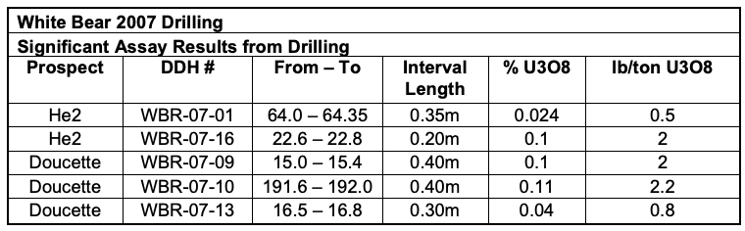

*Retrieved from Pilgrim (2007) report for Commander Resources Ltd.

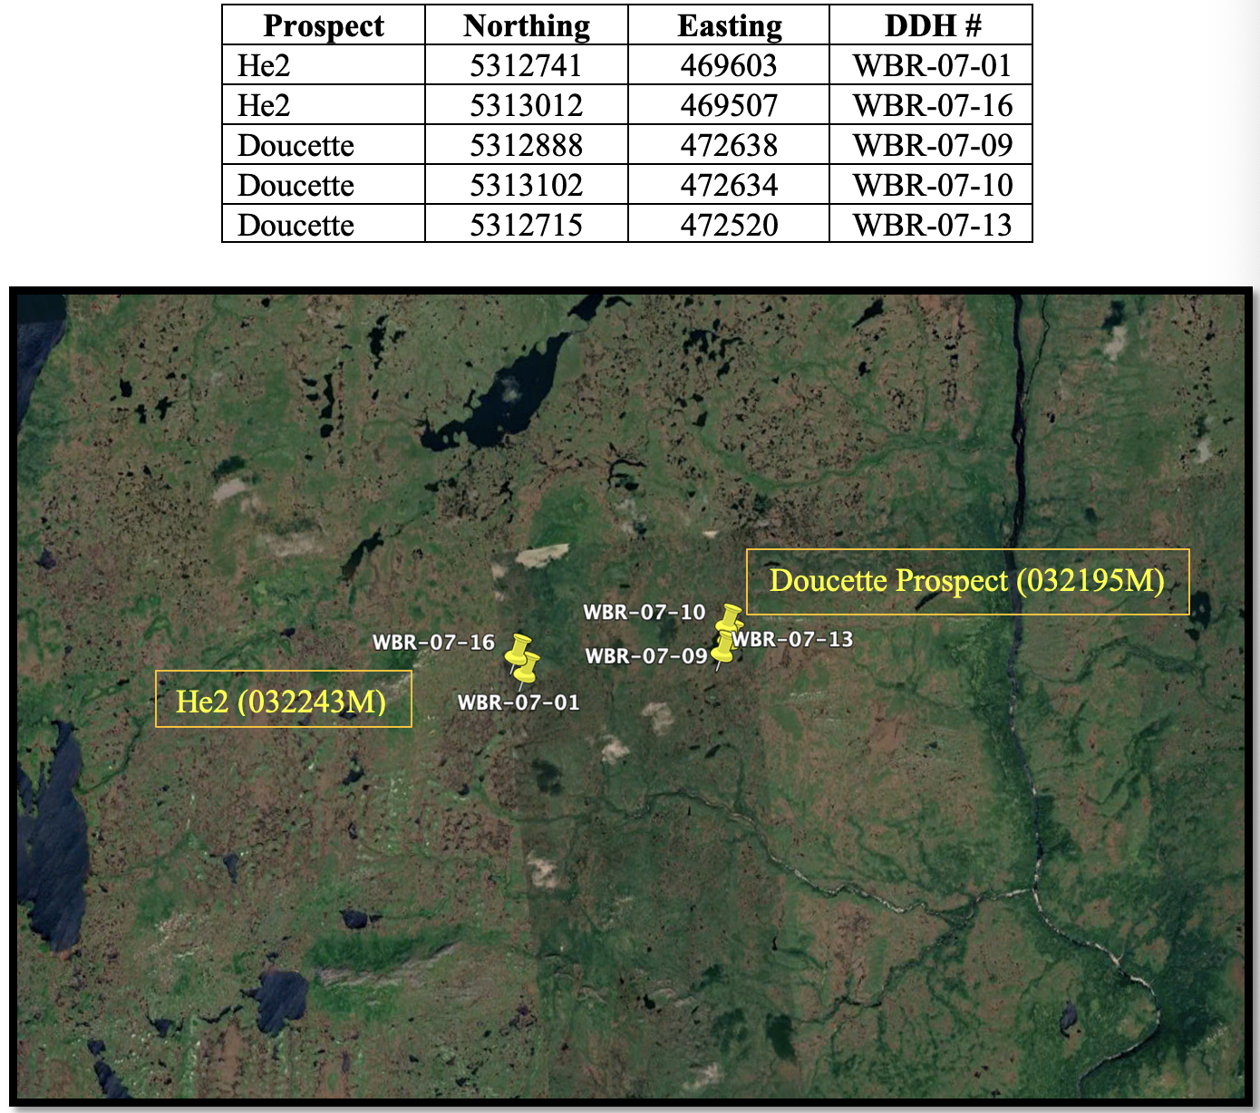

Location of Drillholes

