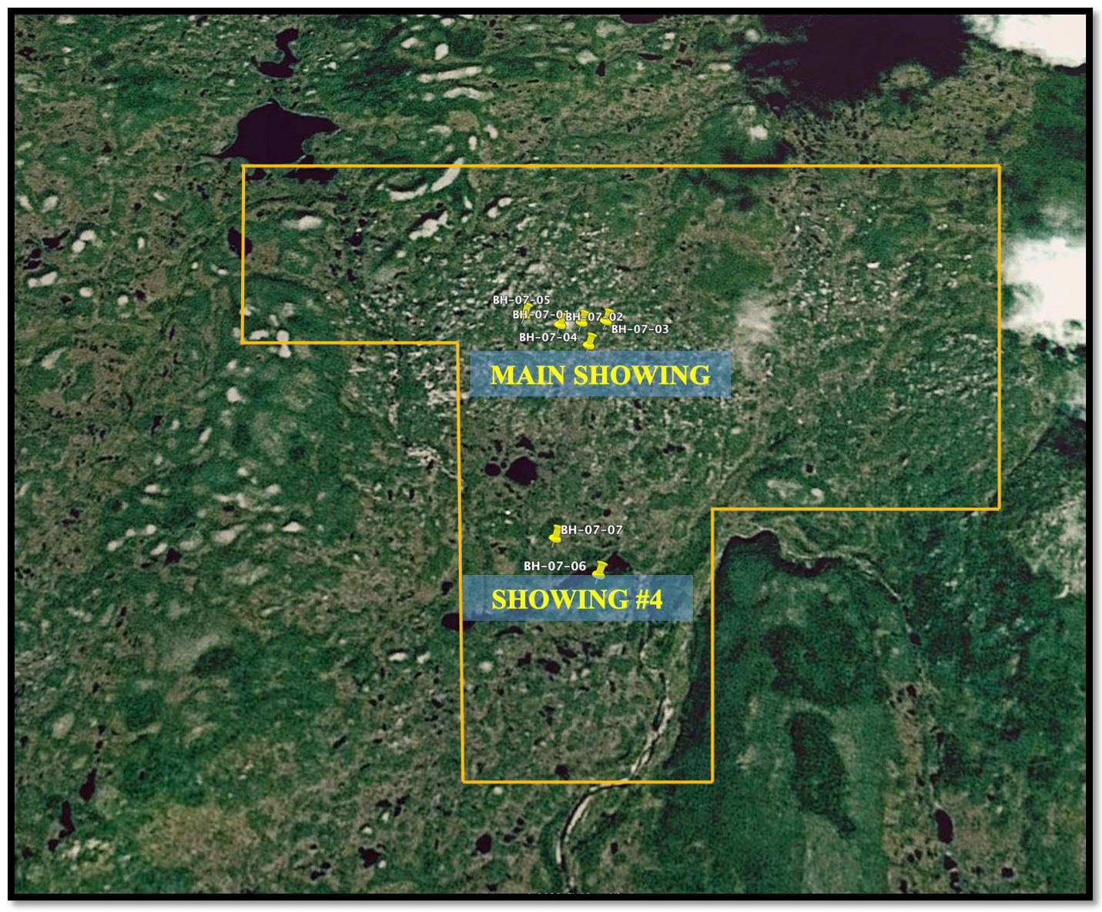

The Blue Hills Property is under-explored and considered highly favourable in hosting large tonnage stratabound uranium deposits. Only 150 meters of the 7-kilometer favourable horizon have been tested by diamond drilling. Other rocks across the property are also deemed favourable to host highgrade uranium mineralization similar to known world class deposits including the large granite related Rossing deposit in Namibia, the felsic volcanic hosted Novazzo Uranium Mine in Italy and the arsenic rich vein type deposits in felsic volcanics of the Great Bear Lake District of Canada (Pilgrim, 2007).

Uranium values in the upper portion of BH-07- 01, just before the fault, which ranged from 0.004 to 0.015% U3O8 are similar to the upper portion of the surface zone. BH-07-02 returned a 3.5 m interval from 15.5 m to 19.0 m running 0.017% U3O8 including a 0.5 metre interval at 0.031% U3O8 (Pilgrim, 2007).

The Main Showing north-south structures appear to have been important in localizing economic uranium grades and the magnetic break along the boulder train is interpreted as fault (Skopik, 1987).

MAIN SHOWING

DESCRIPTION OF DEPOSIT
The showing is restricted to a band of Bay du Nord Group metasediments and metavolcanics, and the Baggs Hills Granite just north of the Peter Snout Granite (Wells, 1981). Rocks of the Bay du Nord Group have been polydeformed and metamorphosed to amphibolite facies.
METAL/MINERAL CONTENT
One grab sample was assayed at 2.88% U and 1400 g/t Mo., Five composite rock chip samples were collected from the eastern end of the bedrock exposed by backhoe approximately 3-6 metres from which previously reported channel samples ran 0.11% U3O8 over 1.5 metres, 0.18% U3O8 over 1.4 metres and 0.14% U3O8 over 1.3 metres. Three of the samples collected contained values ranging from 0.10% U3O8 to 0.18% U3O8 (Commander Resources, Press Release, March 27, 2006).

